Equality from Geometric Theorems

Definition
# Source: AI Source: Provided by: [Data Path: Persons Table -> ID Column: 1, Name_En Column: Motasem Essam] -> From: [ChatGPT] on [7/25/2026]
Equality from Geometric Theorems is a type of geometric equality in which an exact equality is established by applying a geometric theorem to known information.
Unlike Equality from Definitions, where the equality follows directly from the meaning of a geometric term, here the equality is a conclusion derived from a previously proven mathematical theorem.
$$\boxed{\text{Given Information}→\text{Geometric Theorem}→\text{Equality}}$$
For example, if a triangle has two equal sides,
$$AB=AC,$$
the Isosceles Triangle Theorem gives:
$$\boxed{m∠B=m∠C}$$
The angle equality is not part of the definition of an isosceles triangle; it is obtained from a theorem.

Simple Definition
# Source: AI Source: Provided by: [Data Path: Persons Table -> ID Column: 1, Name_En Column: Motasem Essam] -> From: [ChatGPT] on [7/25/2026]
Equality from Geometric Theorems means obtaining an exact geometric equality by applying a known geometric theorem to the given information.
Examples include:
$$\boxed{\text{Vertical Angles Theorem}⇒m∠A=m∠B} \\ \boxed{\text{Isosceles Triangle Theorem}⇒m∠B=m∠C} \\ \boxed{\text{Thales’ Theorem}⇒m∠ABC={90}^{∘}} \\ \boxed{\text{Parallelogram Theorem}⇒AB=CD}$$

Fundamental Concept
# Source: AI Source: Provided by: [Data Path: Persons Table -> ID Column: 1, Name_En Column: Motasem Essam] -> From: [ChatGPT] on [7/25/2026]
A geometric theorem is a mathematical statement that has already been established as true.
When the conditions of the theorem are satisfied, its conclusion can be used to establish an equality.
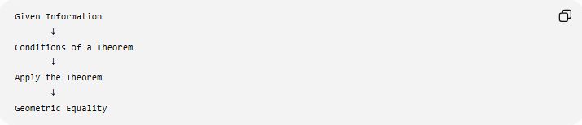
Given Information
↓
Conditions of a Theorem
↓
Apply the Theorem
↓
Geometric Equality
For example:
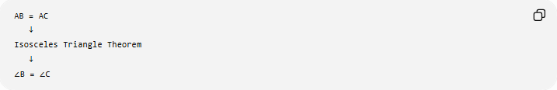
AB = AC
↓
Isosceles Triangle Theorem
↓
∠B = ∠C
Therefore:
$$\boxed{\text{Theorem}→\text{Equality}}$$

Main Types
# Source: AI Source: Provided by: [Data Path: Persons Table -> ID Column: 1, Name_En Column: Motasem Essam] -> From: [ChatGPT] on [7/25/2026]
A practical classification is:
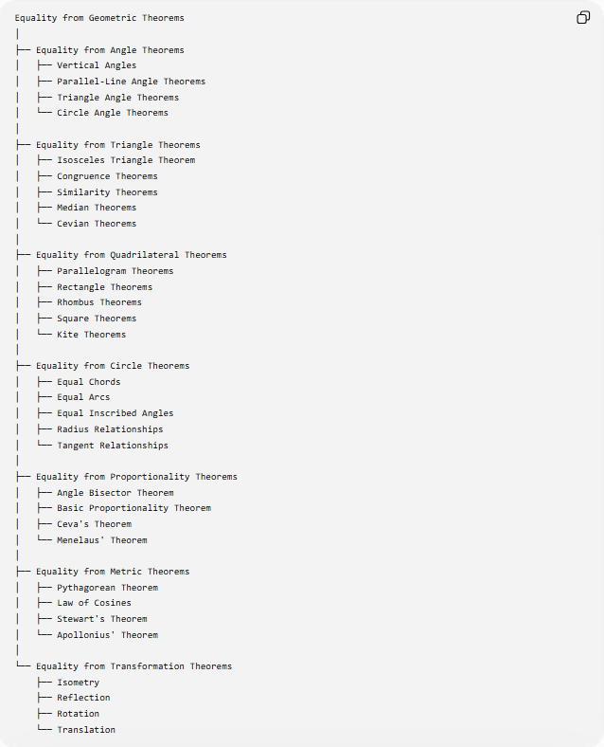
Equality from Geometric Theorems
│
├── Equality from Angle Theorems
│ ├── Vertical Angles
│ ├── Parallel-Line Angle Theorems
│ ├── Triangle Angle Theorems
│ └── Circle Angle Theorems
│
├── Equality from Triangle Theorems
│ ├── Isosceles Triangle Theorem
│ ├── Congruence Theorems
│ ├── Similarity Theorems
│ ├── Median Theorems
│ └── Cevian Theorems
│
├── Equality from Quadrilateral Theorems
│ ├── Parallelogram Theorems
│ ├── Rectangle Theorems
│ ├── Rhombus Theorems
│ ├── Square Theorems
│ └── Kite Theorems
│
├── Equality from Circle Theorems
│ ├── Equal Chords
│ ├── Equal Arcs
│ ├── Equal Inscribed Angles
│ ├── Radius Relationships
│ └── Tangent Relationships
│
├── Equality from Proportionality Theorems
│ ├── Angle Bisector Theorem
│ ├── Basic Proportionality Theorem
│ ├── Ceva's Theorem
│ └── Menelaus' Theorem
│
├── Equality from Metric Theorems
│ ├── Pythagorean Theorem
│ ├── Law of Cosines
│ ├── Stewart's Theorem
│ └── Apollonius' Theorem
│
└── Equality from Transformation Theorems
├── Isometry
├── Reflection
├── Rotation
└── Translation
This is a practical classification, not a single universally standardized taxonomy. Many theorems can establish more than one type of equality.

Equality from the Isosceles Triangle Theorem
# Source: AI Source: Provided by: [Data Path: Persons Table -> ID Column: 1, Name_En Column: Motasem Essam] -> From: [ChatGPT] on [7/25/2026]
Theorem
If two sides of a triangle are equal, then the angles opposite those sides are equal.
If:
$$AB=AC,$$
then:
$$\boxed{m∠B=m∠C}$$
Example
Given:
$$AB=AC$$
and:
$$m∠B={50}^{∘}.$$
By the Isosceles Triangle Theorem:
$$m∠C={50}^{∘}.$$
Therefore:
$$\boxed{m∠B=m∠C}$$
Converse
The converse is also true:
$$\boxed{m∠B=m∠C⇒AB=AC}$$
This provides segment-length equality from angle equality.

Equality from the Vertical Angles Theorem
# Source: AI Source: Provided by: [Data Path: Persons Table -> ID Column: 1, Name_En Column: Motasem Essam] -> From: [ChatGPT] on [7/25/2026]
When two lines intersect, opposite angles are equal.
If lines $AB$and $CD$intersect at $O$:
$$\boxed{m∠AOC=m∠BOD}$$
and:
$$\boxed{m∠AOD=m∠BOC}$$
Example
If:
$$m∠AOC={75}^{∘},$$
then:
$$\boxed{m∠BOD={75}^{∘}}$$
because they are vertical angles.
Equality Type
This theorem establishes:
$$\boxed{\text{Angle Equality}}$$
directly from an intersection relationship.

Equality from Parallel-Line Theorems
# Source: AI Source: Provided by: [Data Path: Persons Table -> ID Column: 1, Name_En Column: Motasem Essam] -> From: [ChatGPT] on [7/25/2026]
When parallel lines are cut by a transversal, several pairs of angles are equal.
If:
$$l_{1}∥l_{2},$$
then:
Corresponding angles
$$\boxed{m∠1=m∠2}$$
Alternate interior angles
$$\boxed{m∠3=m∠4}$$
Alternate exterior angles
$$\boxed{m∠5=m∠6}$$
These are theorem-based equalities.
Example
If two parallel lines are cut by a transversal and:
$$m∠1={65}^{∘},$$
then the corresponding angle has measure:
$$\boxed{{65}^{∘}}.$$

Equality from the Triangle Angle Theorems
# Source: AI Source: Provided by: [Data Path: Persons Table -> ID Column: 1, Name_En Column: Motasem Essam] -> From: [ChatGPT] on [7/25/2026]
The Triangle Angle Sum Theorem states:
$$\boxed{m∠A+m∠B+m∠C={180}^{∘}}$$
Although the theorem itself is an equation rather than necessarily an equality between two separate geometric quantities, it can be used to establish equality.
Example
Suppose:
$$m∠A={60}^{∘}$$
and:
$$m∠B={60}^{∘}.$$
Then:
$$m∠C={180}^{∘}-{60}^{∘}-{60}^{∘} \\ m∠C={60}^{∘}.$$
Therefore:
$$\boxed{m∠A=m∠B=m∠C}$$

Equality from Congruence Theorems
# Source: AI Source: Provided by: [Data Path: Persons Table -> ID Column: 1, Name_En Column: Motasem Essam] -> From: [ChatGPT] on [7/25/2026]
Triangle congruence theorems establish that two triangles have exactly the same size and shape.
The main criteria include:
$$\boxed{\text{SSS}} \\ \boxed{\text{SAS}} \\ \boxed{\text{ASA}} \\ \boxed{\text{AAS}} \\ \boxed{\text{RHS/HL}}$$
If:
$$△ABC≅△DEF,$$
then corresponding parts are equal:
$$AB=DE \\ BC=EF \\ AC=DF$$
and:
$$∠A=∠D \\ ∠B=∠E \\ ∠C=∠F.$$
This is commonly expressed through:
$$\boxed{\text{CPCTC}}$$
Corresponding Parts of Congruent Triangles are Congruent.

Equality from Similarity Theorems
# Source: AI Source: Provided by: [Data Path: Persons Table -> ID Column: 1, Name_En Column: Motasem Essam] -> From: [ChatGPT] on [7/25/2026]
Triangle similarity establishes equal corresponding angles and proportional corresponding sides.
If:
$$△ABC∼△DEF,$$
then:
$$\boxed{m∠A=m∠D} \\ \boxed{m∠B=m∠E} \\ \boxed{m∠C=m∠F}$$
while:
$$\frac{AB}{DE}=\frac{BC}{EF}=\frac{AC}{DF}.$$
Important
Similarity generally gives:
$$\boxed{\text{Angle Equality}}$$
and:
$$\boxed{\text{Ratio Equality}}$$
rather than general side-length equality.
If the scale factor is $1$, then:
$$AB=DE, BC=EF, AC=DF.$$

Equality from the Parallelogram Theorems
# Source: AI Source: Provided by: [Data Path: Persons Table -> ID Column: 1, Name_En Column: Motasem Essam] -> From: [ChatGPT] on [7/25/2026]
A parallelogram has several theorem-based equalities.
If $ABCD$is a parallelogram:
Opposite sides
$$\boxed{AB=CD} \\ \boxed{BC=AD}$$
Opposite angles
$$\boxed{m∠A=m∠C} \\ \boxed{m∠B=m∠D}$$
Diagonals
The diagonals bisect each other.
If diagonals $AC$and $BD$intersect at $O$:
$$\boxed{AO=OC} \\ \boxed{BO=OD}$$
These are important examples of theorem-based geometric equality.

Equality from Rectangle Theorems
# Source: AI Source: Provided by: [Data Path: Persons Table -> ID Column: 1, Name_En Column: Motasem Essam] -> From: [ChatGPT] on [7/25/2026]
A rectangle is a parallelogram with four right angles.
One important theorem states that the diagonals of a rectangle are equal.
If $ABCD$is a rectangle:
$$\boxed{AC=BD}$$
Example
If:
$$AC=12\text{ cm},$$
then:
$$\boxed{BD=12\text{ cm}}.$$
This is a diagonal-length equality obtained from a geometric theorem.

Equality from Rhombus Theorems
# Source: AI Source: Provided by: [Data Path: Persons Table -> ID Column: 1, Name_En Column: Motasem Essam] -> From: [ChatGPT] on [7/25/2026]
A rhombus has four equal sides:
$$\boxed{AB=BC=CD=DA}$$
and its diagonals have important relationships.
The diagonals bisect each other:
$$AO=OC \\ BO=OD.$$
The diagonals of a rhombus are perpendicular:
$$AC⊥BD.$$
The diagonal relationships can be combined with right-triangle theorems to establish additional equalities.

Equality from Square Theorems
# Source: AI Source: Provided by: [Data Path: Persons Table -> ID Column: 1, Name_En Column: Motasem Essam] -> From: [ChatGPT] on [7/25/2026]
A square combines properties of a rectangle and a rhombus.
Therefore:
$$\boxed{AB=BC=CD=DA}$$
and:
$$\boxed{AC=BD}.$$
Its diagonals also bisect each other:
$$AO=OC \\ BO=OD.$$
Thus a square provides several types of theorem-based equality:
- side-length equality,
- diagonal equality,
- segment equality,
- angle equality.

Equality from Circle Theorems
# Source: AI Source: Provided by: [Data Path: Persons Table -> ID Column: 1, Name_En Column: Motasem Essam] -> From: [ChatGPT] on [7/25/2026]
Circle geometry contains many important equality theorems.
Equal chords
In the same circle, equal chords subtend equal central angles.
If:
$$AB=CD,$$
then:
$$\boxed{m∠AOB=m∠COD}.$$
The converse also holds in the same circle.

Equality of Chords from Equal Distances
# Source: AI Source: Provided by: [Data Path: Persons Table -> ID Column: 1, Name_En Column: Motasem Essam] -> From: [ChatGPT] on [7/25/2026]
A theorem states that chords equidistant from the center of the same circle are equal.
If:
$$d\left(O , \overset{‾}{AB}\right)=d\left(O , \overset{‾}{CD}\right),$$
then:
$$\boxed{AB=CD}.$$
This is an example of segment-length equality derived from a circle theorem.

Equality from Equal Arcs
# Source: AI Source: Provided by: [Data Path: Persons Table -> ID Column: 1, Name_En Column: Motasem Essam] -> From: [ChatGPT] on [7/25/2026]
In the same circle, equal arcs correspond to equal chords and equal central angles.
If:
$$\hat{AB}=\hat{CD},$$
then:
$$\boxed{AB=CD}$$
and:
$$\boxed{m∠AOB=m∠COD}.$$
Thus one equality can generate other equalities through circle theorems.

Equality from the Inscribed Angle Theorem
# Source: AI Source: Provided by: [Data Path: Persons Table -> ID Column: 1, Name_En Column: Motasem Essam] -> From: [ChatGPT] on [7/25/2026]
The Inscribed Angle Theorem states:
$$m∠ABC=\frac{1}{2}m\hat{AC}.$$
Therefore, if two inscribed angles intercept the same arc:
$$\boxed{m∠ABC=m∠ADC}.$$
Example
If both angles intercept an arc measuring ${100}^{∘}$:
$$m∠ABC=m∠ADC={50}^{∘}.$$
This establishes angle equality.

Equality from Thales' Theorem
# Source: AI Source: Provided by: [Data Path: Persons Table -> ID Column: 1, Name_En Column: Motasem Essam] -> From: [ChatGPT] on [7/25/2026]
If $AC$is a diameter of a circle and $B$lies on the circle:
$$\boxed{m∠ABC={90}^{∘}}$$
This can be used together with other right-angle relationships to establish equal angles or lengths.
For example, if two angles are each proven to be right angles:
$$m∠A={90}^{∘}, m∠B={90}^{∘},$$
then:
$$\boxed{m∠A=m∠B}.$$

Equality from the Angle Bisector Theorem
# Source: AI Source: Provided by: [Data Path: Persons Table -> ID Column: 1, Name_En Column: Motasem Essam] -> From: [ChatGPT] on [7/25/2026]
The Angle Bisector Theorem states that an angle bisector divides the opposite side proportionally to the adjacent sides.
If $AD$bisects $∠A$in $△ABC$:
$$\boxed{\frac{BD}{DC}=\frac{AB}{AC}}$$
This is primarily a ratio equality.
However, special cases can produce length equality.
If:
$$AB=AC,$$
then:
$$\frac{BD}{DC}=1$$
so:
$$\boxed{BD=DC}.$$
Thus a theorem can convert one equality into another.

Equality from Ceva's Theorem
# Source: AI Source: Provided by: [Data Path: Persons Table -> ID Column: 1, Name_En Column: Motasem Essam] -> From: [ChatGPT] on [7/25/2026]
Ceva's Theorem states that for cevians $AD,BE,CF$in a triangle:
$$AD,BE,CF\text{ concurrent}$$
if and only if:
$$\boxed{\frac{BD}{DC}\frac{CE}{EA}\frac{AF}{FB}=1}$$
This is primarily a theorem of ratio equality and concurrency.
For example, for three medians:
$$BD=DC, \\ CE=EA, \\ AF=FB.$$
Therefore each ratio equals $1$, and:
$$1⋅1⋅1=1.$$
This establishes the concurrency of the three medians.

Equality from Menelaus' Theorem
# Source: AI Source: Provided by: [Data Path: Persons Table -> ID Column: 1, Name_En Column: Motasem Essam] -> From: [ChatGPT] on [7/25/2026]
Menelaus' Theorem establishes a relationship among ratios when three points are collinear.
Using directed lengths:
$$\boxed{\frac{\overset{‾}{BD}}{\overset{‾}{DC}}\frac{\overset{‾}{CE}}{\overset{‾}{EA}}\frac{\overset{‾}{AF}}{\overset{‾}{FB}}=-1}$$
It can be rearranged to establish unknown ratios and, in special configurations, equality of lengths.
Thus:
$$\boxed{\text{Menelaus}→\text{Ratio Relationships}→\text{Possible Length Equalities}}$$

Equality from Pythagorean Theorem
# Source: AI Source: Provided by: [Data Path: Persons Table -> ID Column: 1, Name_En Column: Motasem Essam] -> From: [ChatGPT] on [7/25/2026]
The Pythagorean Theorem states:
$$\boxed{a^{2}+b^{2}=c^{2}}$$
for a right triangle.
It can establish equality of lengths by comparing calculated squares.
Example
Suppose one right triangle has legs:
$$3, 4.$$
Then:
$$c^{2}=3^{2}+4^{2}=25$$
so:
$$c=5.$$
If another segment $DE=5$, then:
$$\boxed{c=DE}.$$
Thus a metric theorem can establish segment-length equality.

Equality from Stewart's Theorem
# Source: AI Source: Provided by: [Data Path: Persons Table -> ID Column: 1, Name_En Column: Motasem Essam] -> From: [ChatGPT] on [7/25/2026]
Stewart's Theorem relates the length of a cevian to the sides of a triangle.
For:
$$BC=a, BD=m, DC=n, \\ AB=c, AC=b, AD=d,$$
we have:
$$\boxed{b^{2}m+c^{2}n=a\left(d^{2}+mn\right)}$$
It can be used to calculate a cevian length and compare it with another known length.
Example
If the theorem gives:
$$AD=10$$
and another segment is known to have:
$$EF=10,$$
then:
$$\boxed{AD=EF}.$$
Thus Stewart's Theorem can be used as a source of segment-length equality.

Equality from Apollonius' Theorem
# Source: AI Source: Provided by: [Data Path: Persons Table -> ID Column: 1, Name_En Column: Motasem Essam] -> From: [ChatGPT] on [7/25/2026]
Apollonius' Theorem relates the sides of a triangle to a median.
If $AD$is a median:
$$BD=DC.$$
Then:
$$\boxed{AB^{2}+AC^{2}=2\left(AD^{2}+BD^{2}\right)}$$
or:
$$\boxed{m_{a}^{2}=\frac{b^{2}+c^{2}}{2}-\frac{a^{2}}{4}}$$
It can be used to calculate a median and establish equality with another segment.
It is also a special case of Stewart's Theorem.

Equality from the Perpendicular Bisector Theorem
# Source: AI Source: Provided by: [Data Path: Persons Table -> ID Column: 1, Name_En Column: Motasem Essam] -> From: [ChatGPT] on [7/25/2026]
The Perpendicular Bisector Theorem states:
A point on the perpendicular bisector of a segment is equidistant from the endpoints of the segment.
If $P$lies on the perpendicular bisector of $AB$:
$$\boxed{PA=PB}$$
Converse
If:
$$PA=PB,$$
then $P$lies on the perpendicular bisector of $AB$.
Therefore:
$$\boxed{P\text{ on perpendicular bisector }⟺ PA=PB}$$
This is a particularly important theorem because it connects loci and distance equality.

Equality from the Angle Bisector Theorem's Converse
# Source: AI Source: Provided by: [Data Path: Persons Table -> ID Column: 1, Name_En Column: Motasem Essam] -> From: [ChatGPT] on [7/25/2026]
The converse of the Angle Bisector Theorem can establish an angle-bisector relationship from a ratio:
$$\frac{BD}{DC}=\frac{AB}{AC}$$
implies that $AD$bisects $∠A$.
Once the angle-bisector relationship is established:
$$\boxed{m∠BAD=m∠DAC}$$
Thus theorem chains can produce equality indirectly.

Equality from Transformation Theorems
# Source: AI Source: Provided by: [Data Path: Persons Table -> ID Column: 1, Name_En Column: Motasem Essam] -> From: [ChatGPT] on [7/25/2026]
Isometries preserve geometric measurements.
An isometry $T$satisfies:
$$\boxed{AB=A^{'}B^{'}}$$
for corresponding segments.
Similarly:
$$\boxed{m∠A=m∠A^{'}}$$
and areas and perimeters are preserved.
Examples of isometries include:
- translation,
- rotation,
- reflection,
- glide reflection.
Example
If a triangle is reflected:
$$△ABC→△A^{'}B^{'}C^{'},$$
then:
$$\boxed{AB=A^{'}B^{'}}$$
and:
$$\boxed{m∠A=m∠A^{'}}.$$

Theorem Chains
# Source: AI Source: Provided by: [Data Path: Persons Table -> ID Column: 1, Name_En Column: Motasem Essam] -> From: [ChatGPT] on [7/25/2026]
A very important feature of geometric equality is that one theorem can lead to another theorem and eventually produce an equality.
For example:
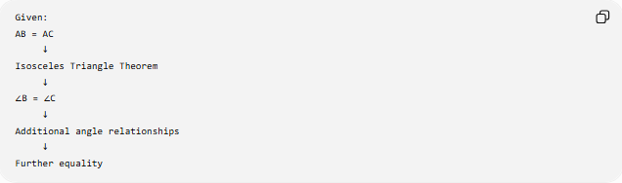
Given:
AB = AC
↓
Isosceles Triangle Theorem
↓
∠B = ∠C
↓
Additional angle relationships
↓
Further equality
Another example:
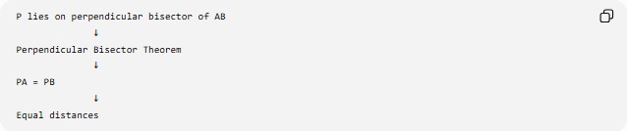
P lies on perpendicular bisector of AB
↓
Perpendicular Bisector Theorem
↓
PA = PB
↓
Equal distances
Another:
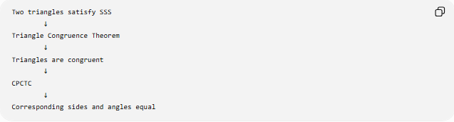
Two triangles satisfy SSS
↓
Triangle Congruence Theorem
↓
Triangles are congruent
↓
CPCTC
↓
Corresponding sides and angles equal

Direct vs Theorem-Based Equality
# Source: AI Source: Provided by: [Data Path: Persons Table -> ID Column: 1, Name_En Column: Motasem Essam] -> From: [ChatGPT] on [7/25/2026]
This distinction is important.
Equality from a Definition
The equality is contained directly in the definition.
Example:
$$M\text{ is midpoint}⇒\boxed{AM=MB}$$
Equality from a Theorem
The equality is derived from a previously proven theorem.
Example:
$$AB=AC⇒\boxed{∠B=∠C}$$
using the Isosceles Triangle Theorem.
Comparison
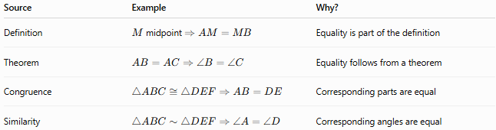
Source | Example | Why?
Definition | $M$midpoint $⇒AM=MB$ | Equality is part of the definition
Theorem | $$AB=AC⇒∠B=∠C$$ | Equality follows from a theorem
Congruence | $$△ABC≅△DEF⇒AB=DE$$ | Corresponding parts are equal
Similarity | $$△ABC∼△DEF⇒∠A=∠D$$ | Corresponding angles are equal

Major Equality Types Produced by Geometric Theorems
# Source: AI Source: Provided by: [Data Path: Persons Table -> ID Column: 1, Name_En Column: Motasem Essam] -> From: [ChatGPT] on [7/25/2026]
Geometric theorems can establish several different kinds of equality.
Segment-Length Equality
$$\boxed{AB=CD}$$
Examples:
- parallelogram theorem,
- rectangle diagonal theorem,
- perpendicular bisector theorem,
- isosceles triangle theorem,
- congruence theorems.
Angle Equality
$$\boxed{m∠A=m∠B}$$
Examples:
- vertical angles theorem,
- parallel-line theorems,
- isosceles triangle theorem,
- inscribed angle theorem,
- similarity theorems.
Distance Equality
$$\boxed{PA=PB}$$
Example:
$$P\text{ on perpendicular bisector}⇒PA=PB.$$
Area Equality
$$\boxed{A_{1}=A_{2}}$$
Examples:
- congruent figures,
- equal-base/equal-height relationships,
- isometries,
- equal-area decomposition theorems.
Perimeter Equality
$$\boxed{P_{1}=P_{2}}$$
Examples:
- congruent figures,
- isometric images,
- corresponding equal side relationships.
Ratio Equality
$$\boxed{\frac{AB}{BC}=\frac{DE}{EF}}$$
Examples:
- Angle Bisector Theorem,
- Basic Proportionality Theorem,
- Ceva's Theorem,
- Menelaus' Theorem,
- similarity theorems.

Classification Summary
# Source: AI Source: Provided by: [Data Path: Persons Table -> ID Column: 1, Name_En Column: Motasem Essam] -> From: [ChatGPT] on [7/25/2026]
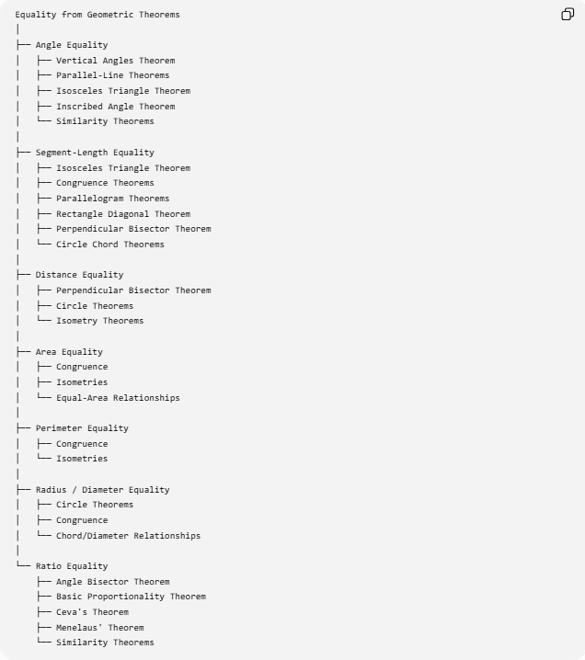
Equality from Geometric Theorems
│
├── Angle Equality
│ ├── Vertical Angles Theorem
│ ├── Parallel-Line Theorems
│ ├── Isosceles Triangle Theorem
│ ├── Inscribed Angle Theorem
│ └── Similarity Theorems
│
├── Segment-Length Equality
│ ├── Isosceles Triangle Theorem
│ ├── Congruence Theorems
│ ├── Parallelogram Theorems
│ ├── Rectangle Diagonal Theorem
│ ├── Perpendicular Bisector Theorem
│ └── Circle Chord Theorems
│
├── Distance Equality
│ ├── Perpendicular Bisector Theorem
│ ├── Circle Theorems
│ └── Isometry Theorems
│
├── Area Equality
│ ├── Congruence
│ ├── Isometries
│ └── Equal-Area Relationships
│
├── Perimeter Equality
│ ├── Congruence
│ └── Isometries
│
├── Radius / Diameter Equality
│ ├── Circle Theorems
│ ├── Congruence
│ └── Chord/Diameter Relationships
│
└── Ratio Equality
├── Angle Bisector Theorem
├── Basic Proportionality Theorem
├── Ceva's Theorem
├── Menelaus' Theorem
└── Similarity Theorems

Relationship to Geometric Equality
# Source: AI Source: Provided by: [Data Path: Persons Table -> ID Column: 1, Name_En Column: Motasem Essam] -> From: [ChatGPT] on [7/25/2026]
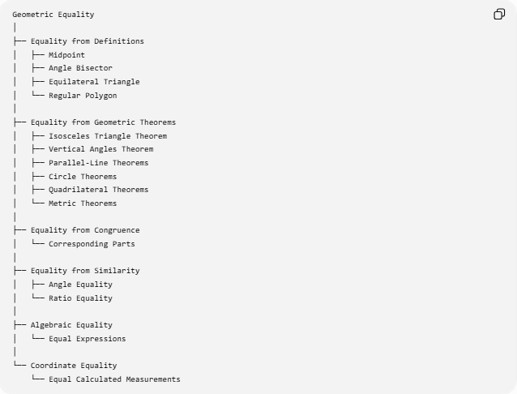
Geometric Equality
│
├── Equality from Definitions
│ ├── Midpoint
│ ├── Angle Bisector
│ ├── Equilateral Triangle
│ └── Regular Polygon
│
├── Equality from Geometric Theorems
│ ├── Isosceles Triangle Theorem
│ ├── Vertical Angles Theorem
│ ├── Parallel-Line Theorems
│ ├── Circle Theorems
│ ├── Quadrilateral Theorems
│ └── Metric Theorems
│
├── Equality from Congruence
│ └── Corresponding Parts
│
├── Equality from Similarity
│ ├── Angle Equality
│ └── Ratio Equality
│
├── Algebraic Equality
│ └── Equal Expressions
│
└── Coordinate Equality
└── Equal Calculated Measurements

Important Distinction
# Source: AI Source: Provided by: [Data Path: Persons Table -> ID Column: 1, Name_En Column: Motasem Essam] -> From: [ChatGPT] on [7/25/2026]
Not every equality associated with a geometric object is necessarily an equality from a definition.
For example:
Isosceles triangle
Definition:
$$AB=AC$$
Theorem:
$$\boxed{∠B=∠C}$$
Therefore:
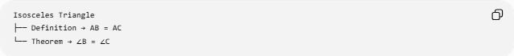
Isosceles Triangle
├── Definition → AB = AC
└── Theorem → ∠B = ∠C
Parallelogram
Definition:
$$AB∥CD, AD∥BC$$
Theorems:
$$AB=CD \\ AD=BC \\ ∠A=∠C$$
So:
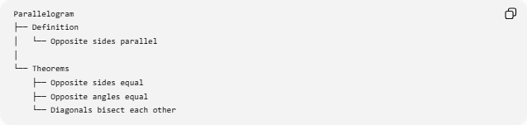
Parallelogram
├── Definition
│ └── Opposite sides parallel
│
└── Theorems
├── Opposite sides equal
├── Opposite angles equal
└── Diagonals bisect each other
This distinction is essential for accurate proof classification.

Key Points
# Source: AI Source: Provided by: [Data Path: Persons Table -> ID Column: 1, Name_En Column: Motasem Essam] -> From: [ChatGPT] on [7/25/2026]
- Equality from Geometric Theorems is equality established by applying a proven geometric theorem.
- It differs from equality that is directly stated by a definition.
- Major theorem-based equalities include:
$$AB=CD \\ m∠A=m∠B \\ PA=PB \\ A_{1}=A_{2} \\ P_{1}=P_{2} \\ \frac{A}{B}=\frac{C}{D}$$
- The Isosceles Triangle Theorem converts equal sides into equal angles.
- The Vertical Angles Theorem produces equal angles.
- Parallel-line theorems produce equal angle measures.
- Congruence theorems produce corresponding equal lengths and angles.
- Circle theorems produce equal chords, arcs, angles, and distances.
- Quadrilateral theorems produce equal sides, angles, and diagonals.
- Metric theorems can establish equal lengths through calculations.
- Proportionality theorems produce ratio equalities.
- A theorem can also be used as part of a chain of reasoning that eventually establishes an equality.

Conclusion
# Source: AI Source: Provided by: [Data Path: Persons Table -> ID Column: 1, Name_En Column: Motasem Essam] -> From: [ChatGPT] on [7/25/2026]
$$\boxed{\text{Equality from Geometric Theorems}=\text{Equality established by applying a proven geometric theorem}}$$
The general structure is:
$$\boxed{\text{Given Information}→\text{Theorem}→\text{Derived Property}→\text{Equality}}$$
Examples:
$$\boxed{AB=AC∠B=∠C} \\ \boxed{l_{1}∥l_{2}∠1=∠2} \\ \boxed{P\text{ on perpendicular bisector}PA=PB} \\ \boxed{ABCD\text{ parallelogram}⟹AB=CD, AD=BC}$$
Thus, geometric theorems are a major source of exact geometric equality, connecting known geometric conditions to new equal lengths, angles, distances, areas, perimeters, radii, diameters, and ratios.

